Setting up the LCD in your Pico

Overview
In this exercise, we are going to learn how to use the ultrasonic sensor. The ultrasonic sensor is used to determine the distance to an object and works in the same way as a bat judges distance using echolocation.
This device has four inputs:
- GND: Ground
- VCC: Voltage. The sensor requires a 5V power source rather than a 3.3V one
- Trig: Sending a signal down this line sends out an ultrasonic pulse.
- Echo: This sends a signal once the ultrasonic pulse is received back.
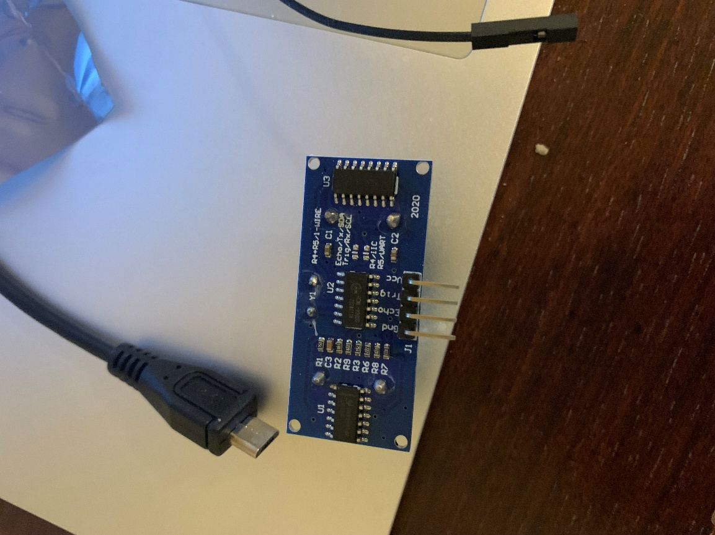

(code adapted from https://docs.sunfounder.com/projects/umsk/en/latest/04_pi_pico/pico_lesson23_ultrasonic.html)
To connect this, you will use the female-to-male jumper cables that come with your kit. This looks like a giant flat rainbow strip with a female socket (hole) at one end, and a male socket (pin) at the other end. You will need to pull off the jumpers- they are stuck together with a weak glue.
Connect the GND pin on the LCD to your ground
Connect the VCC pin to pin 40 on your Pico. With the USB bus facing you, this will be the first pin on your left. The 3.3V pin is the fourth pin on your left.
Connect the trig pin on the sensor to pin 17 on the Pico.
Connect the echo pin on the sensor to pin 16 on the Pico.
Then, set up the sensor in Thonny:
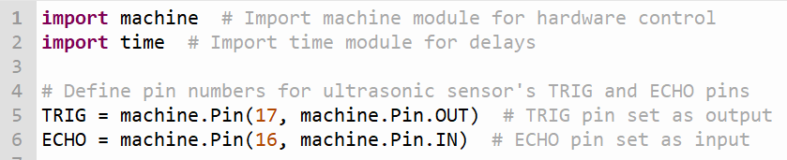
What we are going to do is send a 10 microsecond ultrasonic pulse out. Then, we will measure the time the pulse takes to get back to us. The speed of sound is 343 meters per second. The sound wave has to travel to the object then bounce back. So we divide the result by 2 to get the distance. We then divide by 10000 to convert from meters per second to centimeters per microsecond. (100 centimeters in a meter, 1 million microseconds in a second, divide the top by the bottom gets 1/10000).
Write the following code:
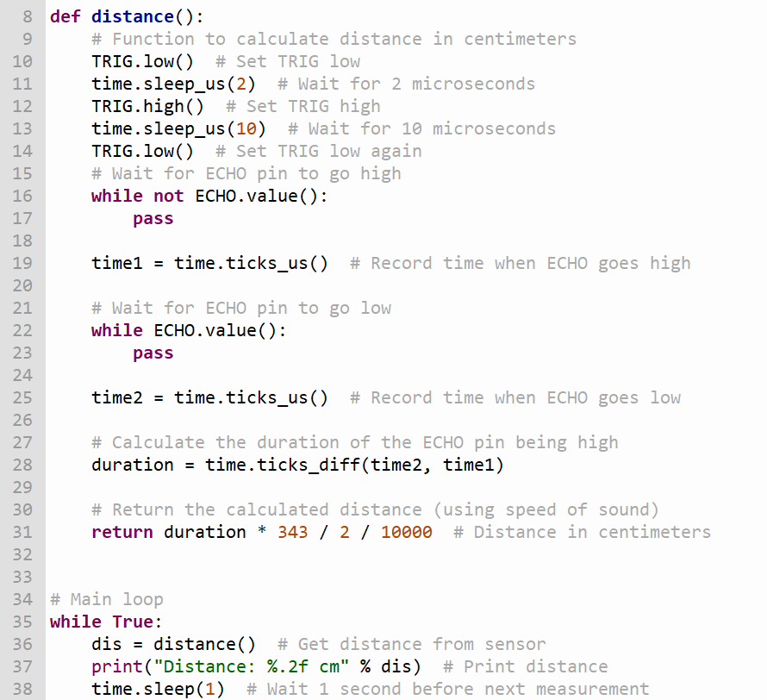
If everything works, putting an object in front of the sensor should cause the sensor to measure the distance to the object. In my case, I pointed my sensor at the wall on my left.
