Setting up the LCD in your Pico

Overview
In this exercise, we are going to learn how to use the LCD 1602 liquid crystal display. This device has four inputs:
- GND: Ground
- VCC: Voltage. The LCD requires a 5V power source rather than a 3.3V one
- SDA: Serial data line
- SDC: Serial clock line
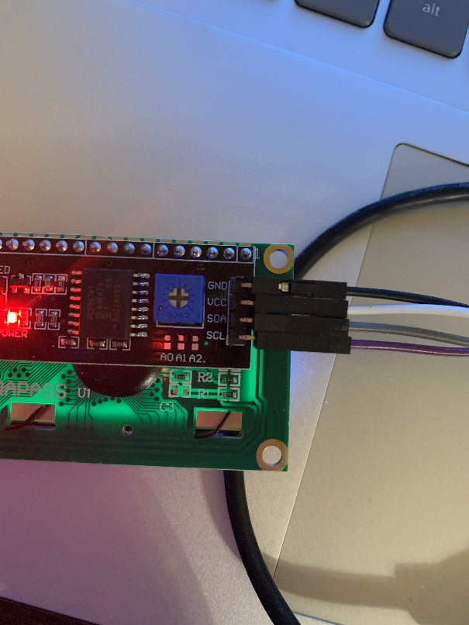

To connect this, you will use the female-to-male jumper cables that come with your kit. This looks like a giant flat rainbow strip with a female socket (hole) at one end, and a male socket (pin) at the other end. You will need to pull off the jumpers- they are stuck together with a weak glue.
Connect the GND pin on the LCD to your ground
Connect the VCC pin to pin 40 on your Pico. With the USB bus facing you, this will be the first pin on your left. The 3.3V pin is the fourth pin on your left.
Connect the SDA pin on the LCD to pin 9 on the Pico. This is the I2C1 SDA pin.
Connect the SDA pin on the LCD to pin 10 on the Pico. This is the I2C1 SDC pin.
Then, write the following code:
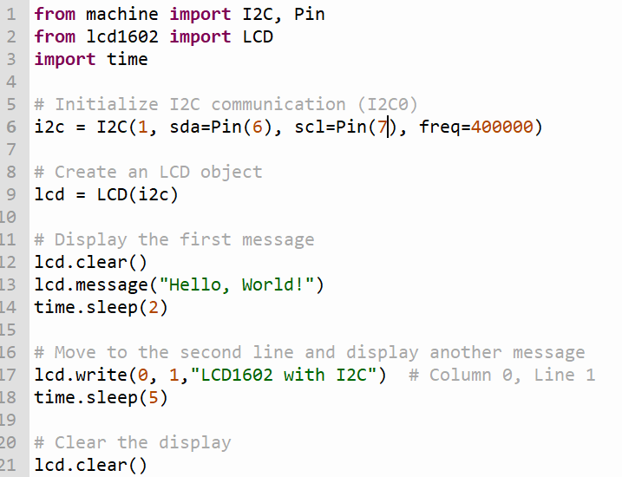
You should observe some text appear on the LCD screen. After 2 seconds, more text will appear after it. Then, after 5 seconds, the text will disappear.
Exercise 2: Combine LCD with the DHT11
Set up a DHT 11. Set it up so your LCD screen will display the current temperature. Temperature in Farenheit will appear on the first line, and the temperature in Celsius will appear on the second line. The temperature will be refreshed every 2 seconds.
If you forgot how to set up a DHT11, refer back to the corresponding lab.
