Setting up a Switch in Your Pico

Overview
In this exercise, we are going to create an input device to the Pico- a switch. In our last exercise, we created an output device. Thus, the pin we used sent electricity to the device. Here, the pin will be receiving electricity. Electricity will therefore have to be generated elsewhere, in our case through the 3.3V pin that comes with the Pico.
We will also be learning how to use the serial port to monitor events on the Pico.
Exercise 1: Our Circuit
Take out the following items:
- The breadboard from the last exercise with the LED, etc. in place.
- A short green wire
- A long white wire
- 1 1K ohm resistor (brown, black, black brown, gold)
- 1 pushbutton switch
We are going to assemble these as per the following diagram:
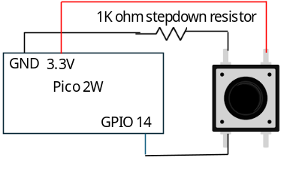
Make sure the Arduino is not plugged in before you do this. Also, make sure you preserve the circuitry from the previous exercise. In specific, we need the ground wires in place. Then:
- Connect the pushbutton across the ravine on rows 30 and 33.
- Connect the short green wire from the power strip to the pushbutton on line 33
- Connect the 1K ohm resistor from the ground strip to the pushbutton on line 30.
- Connect the white wire from the pushbutton to GPIO 14.

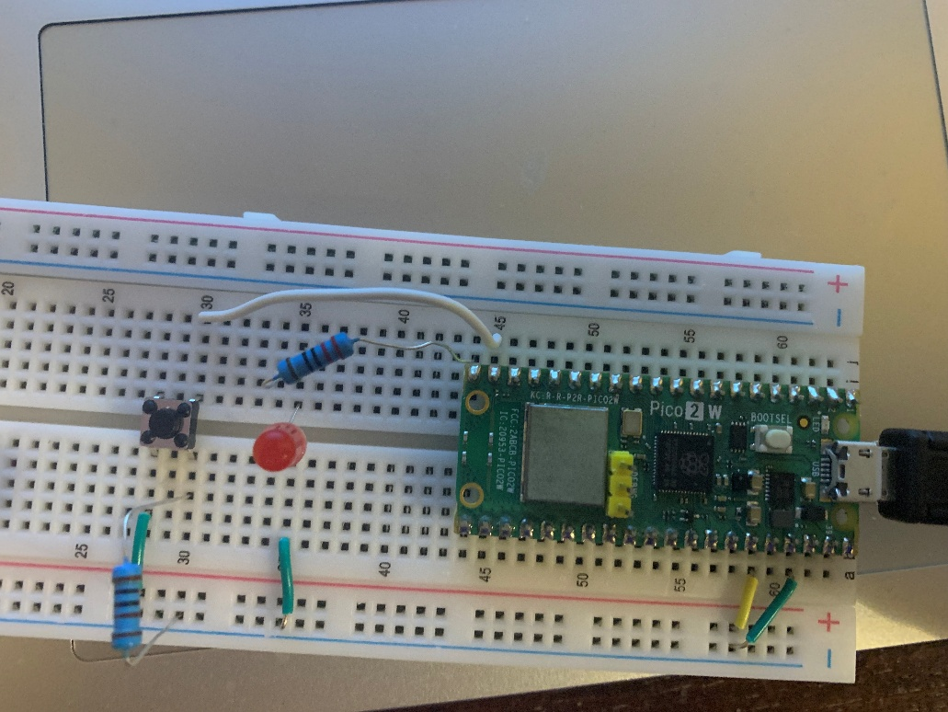
Exercise 2: Our Code
Once you are sure you got this right, plug your Arduino into your computer. Go to the Thonny IDE and go to File\New
In the new sketch, type the following:
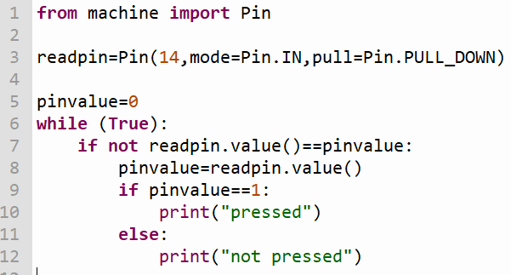Run the code. This is what you should see every time you press the pushbutton.
