Setting up the DC Motor in the Pico

Overview
In this exercise, we are going to learn how to turn on and run a motor using the Pico.
Exercise 1: The DC Motor and the TA6586 Chip
Inside your Pico kit, there should be a DC motor.
We also will need the TA6586 chip, which looks like this:
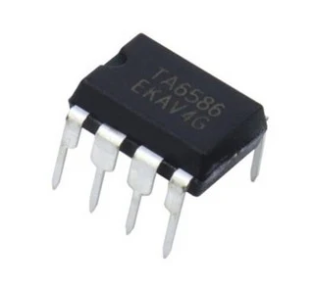
The TA6586 chip is used to manage a simple motor. It is capable of managing two motors running in tandem. The TA6586 is pretty simple. It just turns motors on or off. In contrast, the L293D (for example) can adjust the speed of the motor.
Observe that there is a notch on the top of the TA6586. This denotes which side is “up.”
This is what each of the 8 pins on the TA6586 do.
Notched end of L293D
1: BI- Backwards input. If electricity is sent here and not to FI, the motors will spin backwards. | 8: BO. Backward output. Powers 1 motor
2: FI. Forwards input. If electricity is sent here and not to BI, the motors will spin forward. | 7: BO. Backward output. Powers a second motor.
3: GND. Ground pin. | 6: FO: Forward output. Powers 1 motor.
4: VCC. Power pin. | 5: FO: Forward output. Powers a second motor.

We are going to assemble these as per the following diagram and chart:
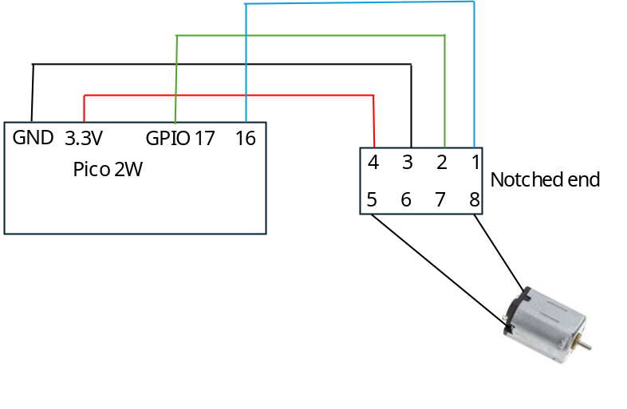
Pin on TA6586 | Connects to | Where
1 | Pico | Pin 16
2 | Pico | Pin 17
3 | Ground strip
4 | Power strip
5 | Motor | One of two motor connectors (black one- doesn’t really matter)
8 | Motor | One of two motor connectors (red one- doesn’t really matter)

Exercise 2: Our Code
What we are going to do is spin the motor one way for two seconds. Then, we’re going to spin the motor the other way for two seconds. To flip the motor spin, we’re going to send opposite signals on pins 16 and 17. When pin 16 is high, pin 17 is low and vice versa.
