Programming the Pico Gyroscope in Python
The MPU 6050 is a gyroscope. The gyroscope outputs three critical position values: Tilt angle forward/backward on the X axis, tilt angle left/right on the Y axis and the rotation of the board relative to the earth on the Z axis. It also outputs the acceleration of the board on each of these three axes. In this exercise, we are going to use the forward/backward tilt (x axis) and left/right tilt (y axis) to move a horse on screen.
Exercise 1: Install Libraries
To use the MPU 6050, we need to install some libraries onto the Pico. You can find the libraries here: https://codeload.github.com/sunfounder/universal-maker-sensor-kit/zip/refs/heads/main
Download the libraries and unzip them into a directory.
In Thonny, go to View\Files
This will open a files tab on the left.
Go to the directory you unpacked the zip in. In that directory, go to raspberry_pi_pico\libs
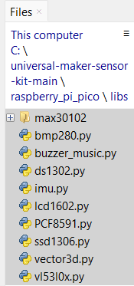
You should see a bunch of .py files. Right click those files and select Upload to /
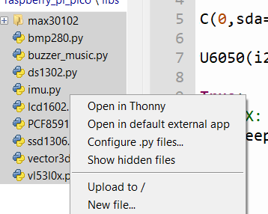
This transfers those files to your Pico.
Exercise 2: Getting your MPU 6050 to Work.
The MPU 6050 uses an I2C (inter-integrated circuit) to communicate. This is fundamentally a serial communication. As with all serial communication, you need a line to do the communication (SDA- serial data, and a second line to synchronize the clock (SCL- serial clock line).
Only certain pins on the Pico can do I2C communication. Fortunately, some of our most favorite pins, pin 16 and 17 are I2C pins on I2C bus 0. The Pico 2 has two I2C buses, Bus 0 and Bus 1.
Connect your MPU 6050 as follows.
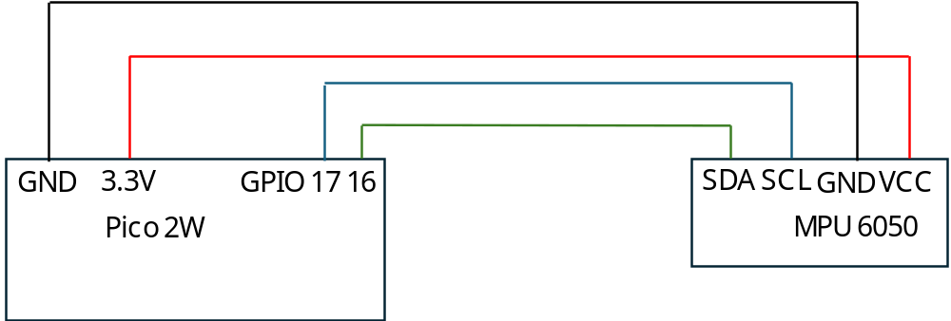
- Ground to ground
- 3.3V to VCC
- Pico Pin 17 to SCL
- Pico Pin 16 to SDA
Then type the following code:
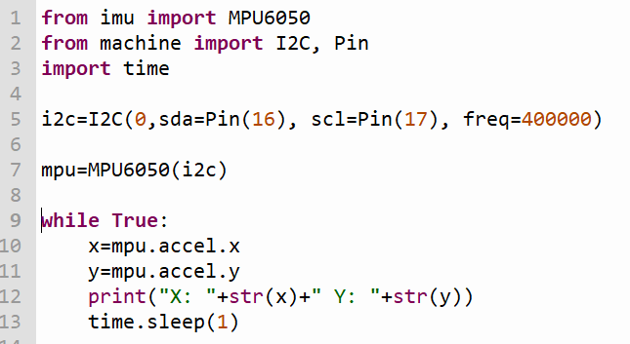
Test your code. Observe that when you tilt your board to the left, the X number will be a big positive number (>0.5). When you tilt to the right, it will be a big negative number (<-0.5). When you tilt down, the Y number is a big negative and when you tilt up, it is a big positive.
Note the numbers you get will depend on how you laid out your MPU 6050. I had mine so the VCC was facing away from the Pico.
Exercise 3: Moving The Horse
Erase the code from while True:
The horse can be seen at:
https://cecilchua.online/arduino/gyrohorse.htm
The way this code works is every 100 microseconds, the web app reads a file at https://cecilchua.online/arduino/horsedir.txt. If this file says “up,” the horse will go up, “down,” the horse will go down, etc.
The code for the horse animation (in JavaScript and HTML is):
<!doctype html>
<html>
<head>
<script>
var horsex=0;
var horsey=0;
var leftpos=250;
var toppos=250;

function animloop(){
horsehandler=setInterval(horseanim,100);
whichhorse=0;
function horseanim(){
horse.src='horse'+whichhorse+'.png';
whichhorse++;
if (whichhorse==12)
whichhorse=0;
leftpos+=horsex*5;
if (leftpos<0)
leftpos=0;
if (leftpos>500)
leftpos=500;
toppos+=horsey*5;
if (toppos<0)
toppos=0;
if (toppos>500)
toppos=500;
horse.style.left=leftpos+"px";
horse.style.top=toppos+"px";
const xhttp = new XMLHttpRequest();
xhttp.onload = function() {
var whichdir = this.responseText;
if (whichdir=='LEFT'){
horsex=-1;
horsey=0;
}
else if (whichdir=='RIGHT'){
horsex=1;
horsey=0;
}
else if (whichdir=='UP'){
horsex=0;
horsey=-1;
}
else if (whichdir=='DOWN'){
horsex=0;
horsey=1;
}

}
xhttp.open("GET", "./horsedir.txt", true);
xhttp.send();
}
}

function animsetup(){
animloop();
}
</script>

</head>
<body onload="animsetup();">
<img id="horse" style="position: absolute; left: 250px; top: 250px;" src="horse0.png" />
</body>
</html>

The horsedir.txt file in turn is modified by a PHP file called gyroread.php. This file takes an instruction called dir, and simply writes it to the file. Here’s the code:
<?php
$myread=$_REQUEST['dir'];
$fp=fopen("horsedir.txt","w");
if ($myread=='LEFT' || $myread=='UP' || $myread=='DOWN' || $myread=='RIGHT')
fwrite($fp,$myread);
fclose($fp);
echo 'OK';
?>
Accordingly, what our Arduino code must do is take the gyro directions and translate those into the commands, “UP,” “DOWN,” “LEFT,” and “RIGHT.”

We first have to log in. Add the libraries network and socket.
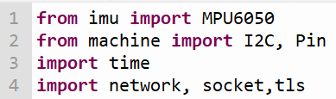
Then add code to connect to the web. This code should be familiar to you:
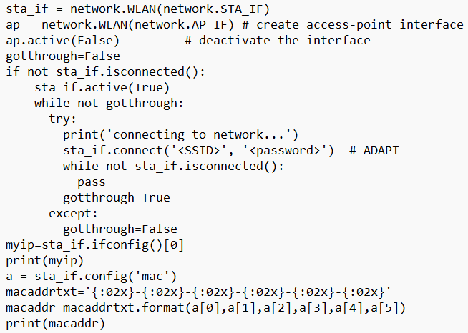
We next have to create our connection to the web server.
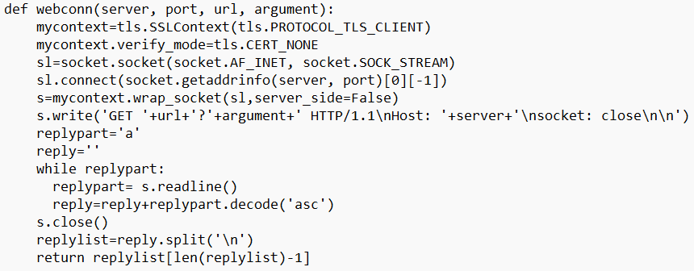

We now want to read the x and y values of the accelerometer. If the values are large, assume the user is tilting the Pico in the appropriate direction.
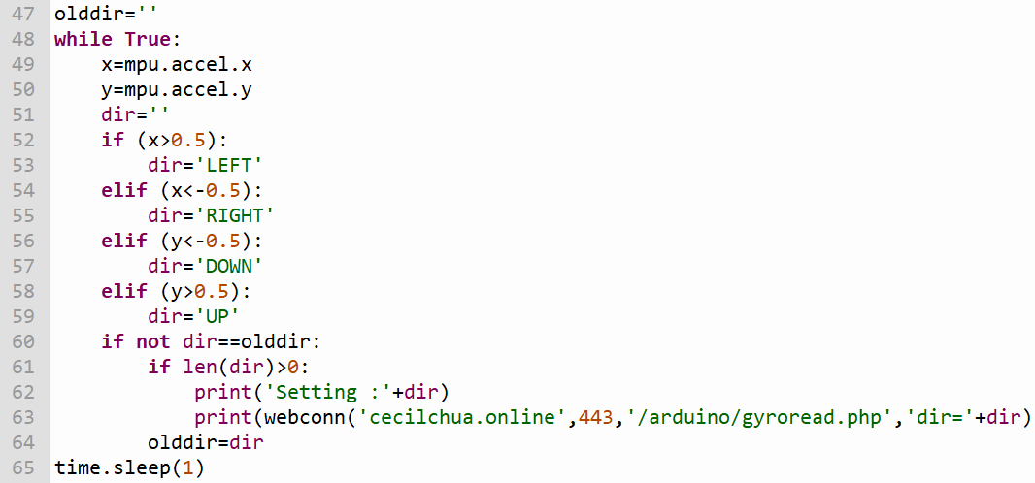

Once you get everything working, observe how tilting your Arduino causes the horse’s movement to change direction (after a bit of a delay).

