Setting up a Speaker in Arduino

Overview
In this exercise, we are going to learn how to play music from the mini speaker.
Exercise 1: The Piezoelectric Buzzer
Take out the following items:
- The PiezoElectric Buzzer
- A 1K ohm resistor
- 2 short wires
- 1 long wire
- 1 S8050 transistor
- Passive buzzer
It may be a little difficult to figure out which is the S8050. The S8050 has 3 prongs. There are a total of four objects in your kit with 3 prongs, the S8050 (there are 2 of them), the S8550, and the IR receiver. Take all four of them out and compare them. The IR receiver has legs that are slightly curved. There are two S8050s, so take one of the three pronged devices that looks the exact same as the other.
You have two buzzers. They are on a foam pad together with the IC chips and the numeric displays. One of them has a sticker that says “Remove seal after washing.” That is the one you want. If you flip both buzzers over, one of them has an integrated circuit. That is the one you do not want.
We are going to assemble these as per the following diagram. Note the long end of the buzzer faces towards power:
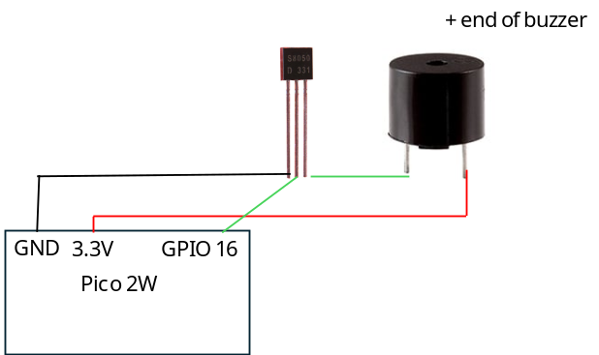
The transistor is used here as an amplifier to strengthen the voltage of the electricity pulse to the buzzer, making the buzzer louder.
Exercise 2: Frequency Code
We will need the Pin and PWM (Pulse Width Modulation) classes from machine and the time library.
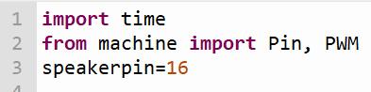
Pulse width modulation is a special technique digital devices use to simulate analog waves. Instead of sending a single continuous 1 signal, the digital pin sends the signal in very fast pulses, which then looks like an analog wave.
The following code gets the speaker to play a musical note:
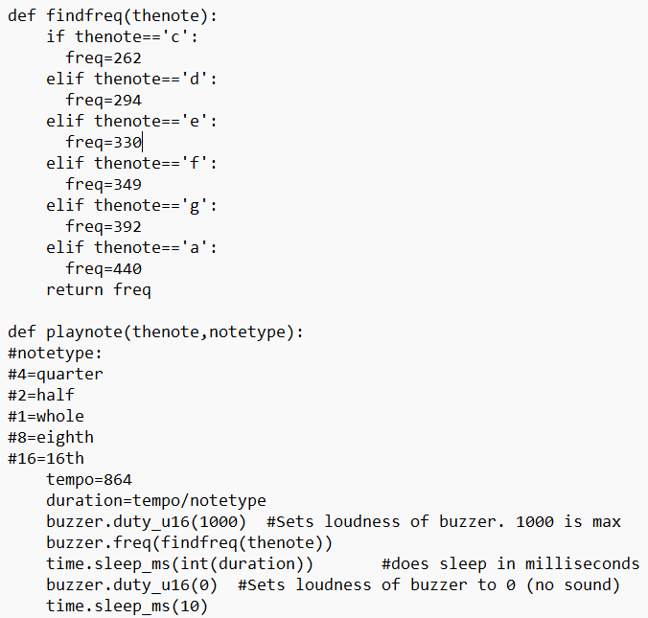
The code takes in two inputs- the note and the duration of the note in metric time set to a tempo approximating cantabile.
Exercise 3: Our Code
Now we will play our song. We will play Mary Had A Little Lamb, which is:
- E4 D4 C4 D4 E4 E4 E2
- D4 D4 D2 E4 G4 G2
- E4 D4 C4 D4 E4 E4 E2
- D4 D4 E4 E4 C2 (rest 2)
If you’re wondering, the notation given is a simplified version of actual computer music notation as used on music typesetting systems like LilyPond https://lilypond.org/text-input.html.
Now, let’s play our song.
