LED With Pico
Exercise 1: Connecting the Pico 2W to the Breadboard
seat the Pico onto the board with the male header pins like this:
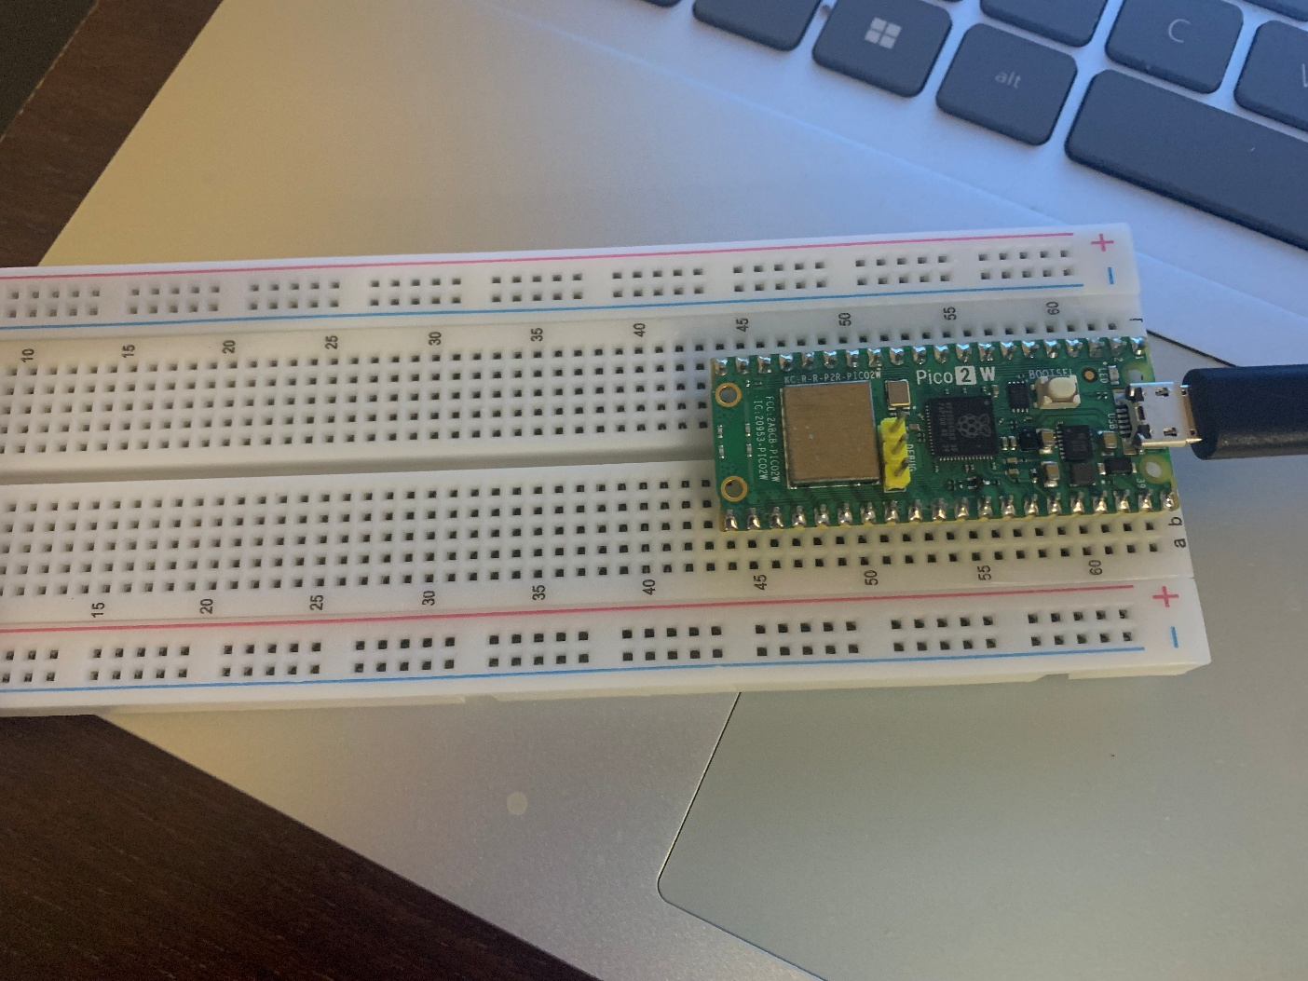

Then, connect the Pico ground to the blue ground stripe and the Pico 3.3V power to the red power stripe.
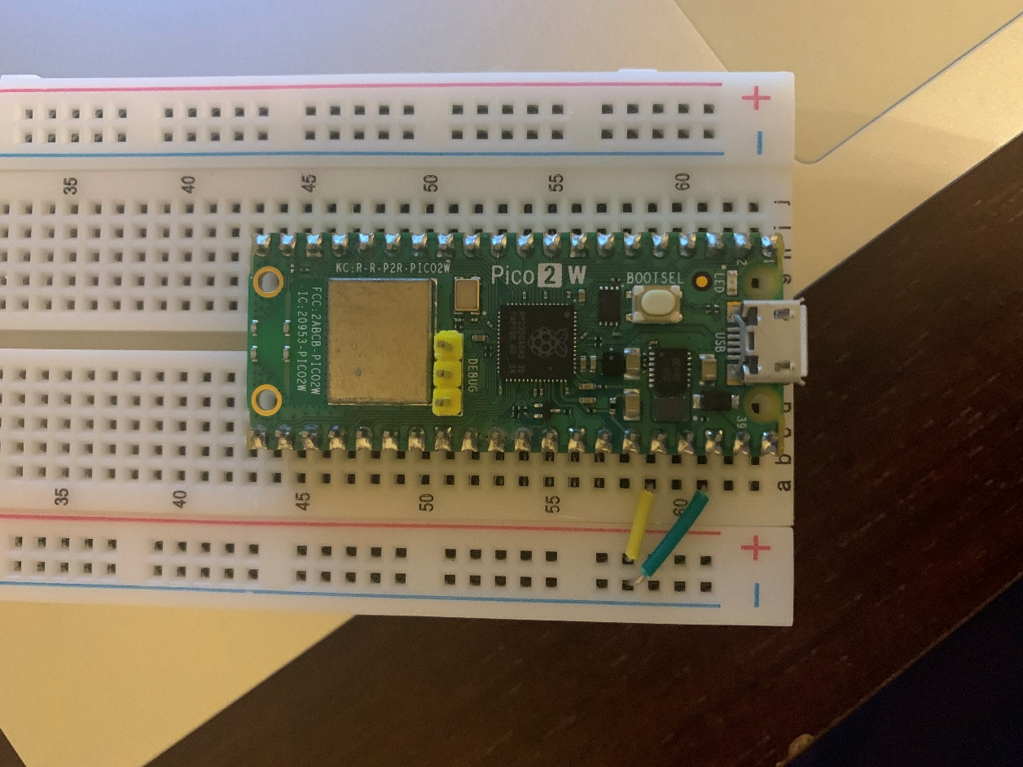
This is the layout of the Pico 2W:
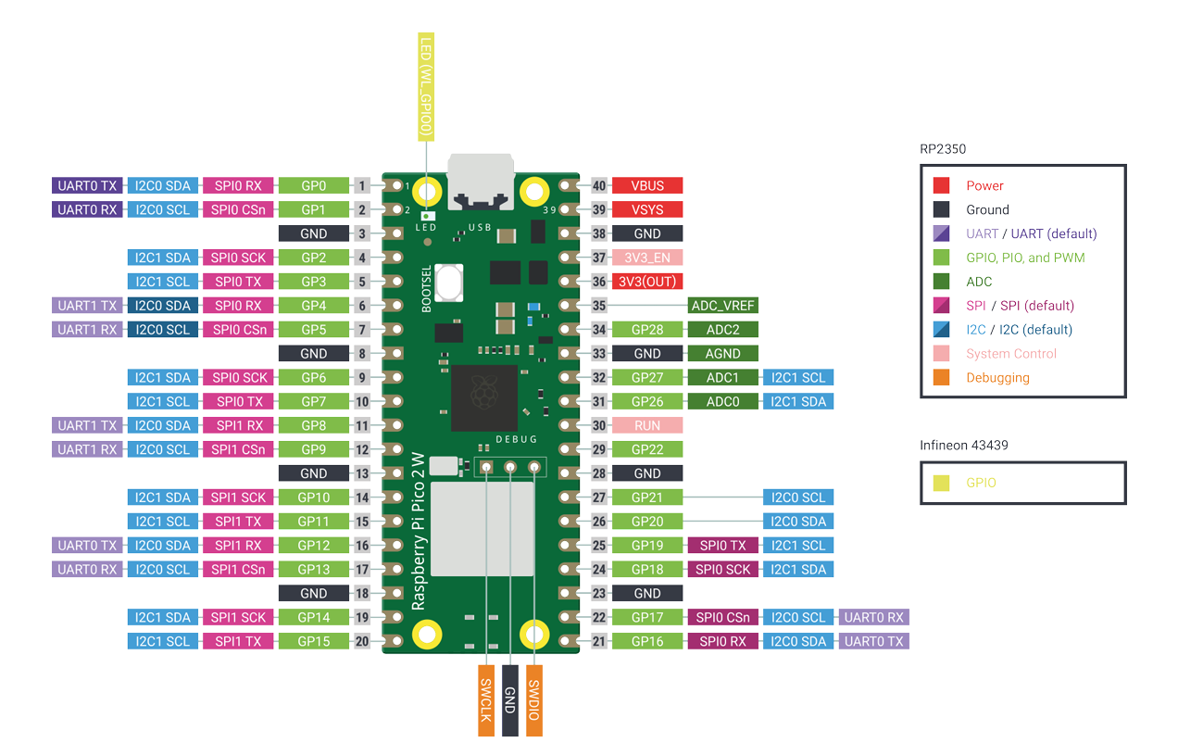
(From https://datasheets.raspberrypi.com/picow/pico-2-w-pinout.pdf)
Note the pins labeled GP#. That number is the number you will put into code to use that pin.
Exercise 2: Our First Circuit
Take out the following items:
- Short green wire
- 1 220 ohm resistor (red, red, brown, gold)
- 1 red diode
We are going to assemble these as per the following diagram:
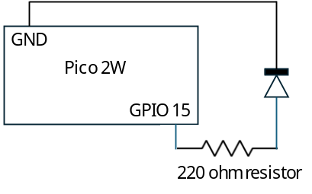
We will do this as follows:
- Connect the resistor to GPIO15 on the Pico 2W and a slot on row 35
- Connect the LED across row 35. The short wire is on the left.
- Connect the short green wire from row 35 to the ground strip
Your circuit should look like the below picture.
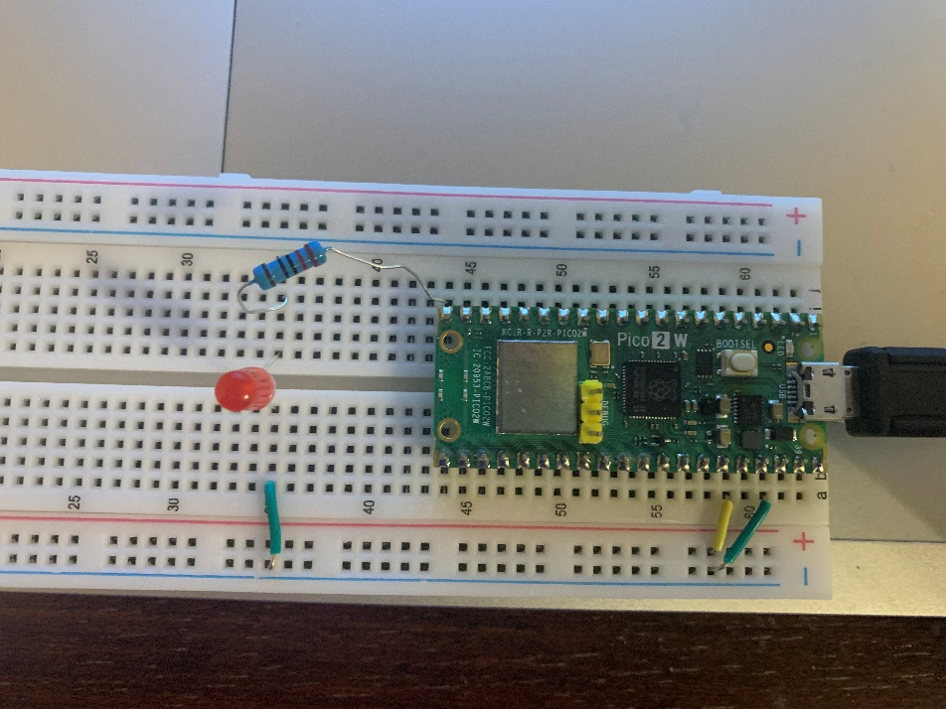

Once you are sure you got this right, plug your Pico into your computer. Go to the Thonny IDE and go to File\New

In the new sketch, type the following:
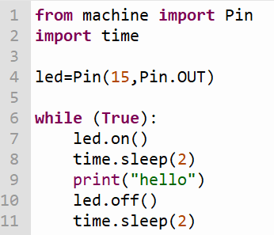
Click on the play icon to run the code. If all goes well, it should connect to the Arduino. If not, hit the stop button then play.

If all goes well, what should happen is the LED on your Arduino should flash on and off once every 2 seconds.

